Northwest Missouri Financial Women’s Meet & Greet
Join us at 6:00 pm on Thursday, October 12th for our monthly meeting. Meet the members, network with other ladies in the financial industry, learn about topics that are relevant to banking & leadership, and see what NMFW does for our local communities.
Our guest Speaker is Sgt. Hux from the Missouri Highway Patrol. His topic is Human Trafficking.
Meeting location: Stoney Creek Hotel
1201 N. Woodbine Rd.
St. Joseph, MO 64506
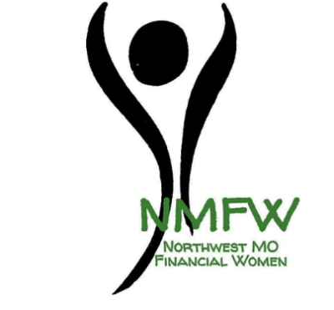

Cost of the meeting is $20. You can become a NMFW member for $20 and attend the meeting at no cost. Cash or check paid to NMFW at the door. RSVP by October 10th to holsen@nvb.com.

